ISVAKU

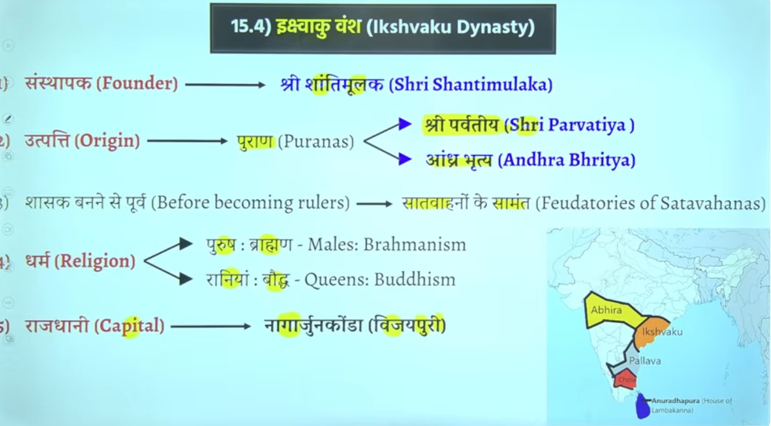

Iskvakou vansh bahtu sare hue hai bharat me ke pracheen kaal me ramayna kaal ke time per iskvaku vansh tha
Abhe hume jis dynasty ke baat kar rahe hai wo hume later ancient historyke period me dekhne ko milta hai

Andhrabratya naam satvhaano k lyie bhe use hota hai
Q shree parvateeya kise kaha gaya hia to answer isvakeu vansh ke rajao ko

Shaahak bane se pahle ye satvahna key aah samant the
Bhumi anudaan ke pratha hai wo samant vaad ko janm dege aur jo ultimately shaktishaale samant hai ya jo powerfule samant hai wo state ya rajya ke isthpana kar lenge wo state ko develop kar lege

Andharaprasdsh me isvaku ka shaashan raha hai
Capital nagarujunkonda ya vijayepure bhe bolte hia usko

Capital andrapradesh wale region me is the the

Vakatak dynasty

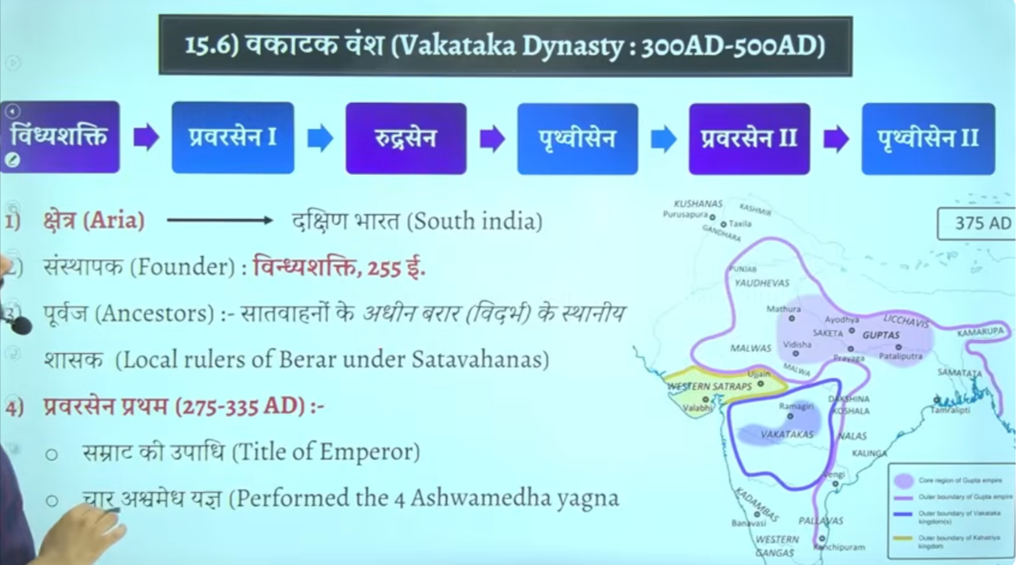

Vaktak vansh ne bhe lagbhag 200 saalo tk shashan kyat ha
Inke shashan kaal ke bare me intresting baat ye hai ke ye gupta kaleen shashako ke samkaleen he shashan karenge
Gutpat empire north me
Uske neeche vaktaka
And in dono ke center me west me western shatrapas (Shakas) honge

Changrautpa second ke bete ka naam tha prabhavate unke betae ka nam tha prabhavati inhone apne beti ka shakdi vakatak vansh ke rajaj rudrasena second se ke the
Inke shadi changraptua second ke bete prabhavit gupta se hue the

Gupta ne shadi k uke
Kuki vakatak ek abhaut acha jareya tha shako ko harane ka kuki agar dono side se attack kar dyia jaye to asane se hara sakte the kuki shaka in dono ke center west me the
To changratuap second ne aisa soch kar shadi ke the aur aisa hua bhe
Aur fir uske baad ek ghtna bhe hog ae ki shadi ke such ssaaal bdd rudrasena second ke death hog ae the
Unke do bete the but dono minor the alpvayask the to prabhavit gutpa ne shasan kyai tha to prabhavit gutpa ka shasank kaal ko swarn kaala maan gaya tha
Kuki gupto se vakatak ke sambandh bahtu ache rahe
Iske bad shako ke bhe khtm kar dyia gaya tha

To vaktak ka mahtavha ye hai ke ye gutpa ke samkaleen contemporty he shahsan karenge

Inke Chetra andrhapdes, Karnatak , mahrasta, telangal ka cetra tha suth me
Inke samkaleen bahut sare rjaa the jaise
Kadamba dynasty karnatka vale
Ganga vansh hai kerla ke ass paas
Pallav hai vengi hai kalinga hai nala hai
Aise bahtu sare chote chote dynasty the
Tampralipti bandargha pashcim Bengal me hai yellow se on map

Inke founder the = Vindhya shakti

Inke ancestor local ruler the satvhaahan ke adhen barar vidharm ke local ruler the starting me

Praveersena firsth ne ashvamedh ke upadi dharan ke the aur char ashvamedh yagya kye the

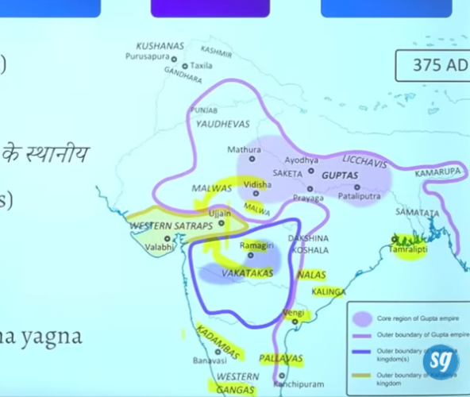

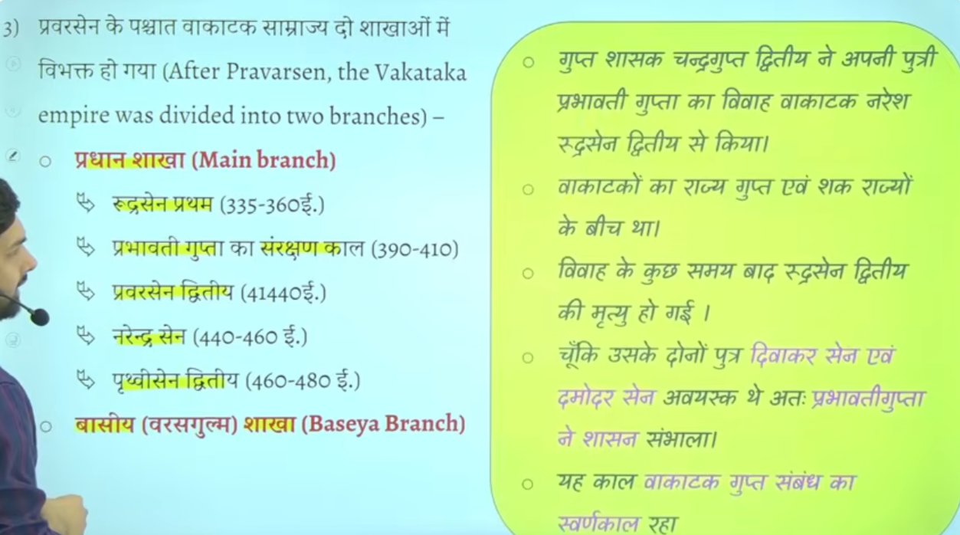
Praversen ke baad vakatak do alag alag shakaho me baat gayay tha ek Pradhan shaak dusre basyesa branch
Pradhan shaka me imporatna mukhya shashak hue the rudrasena first aur jo dyai hai

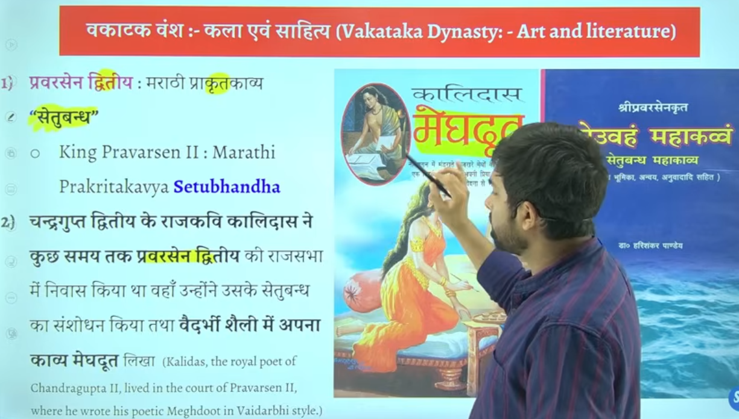

Praversena second ne ek maradi prakratkavya likha tha setubandh
Mahan marathi kavaya hia setubandh jiske rachna praversena second ne ke the jo ke vaktak raja tha
Means vaktak raja praversena second ne ke the

Praversena second jb setubandh ke rachna kar raeh the to unhe usme help chaye the
Chandragutpa second ke darbari kavi mahavakiavi kalidas vkatak k rajya me akar rahe the
Wahah per unhone na sirf setubandh me sansshodan kyia balik
Yahe per unhone apne ke mahan book likhe megadoot

But ikso kuch historian sahe nahi mante
Yaha se sawal setubandh se banta hai dusra saval banta hai prabhavati gupta se and ruderasena se

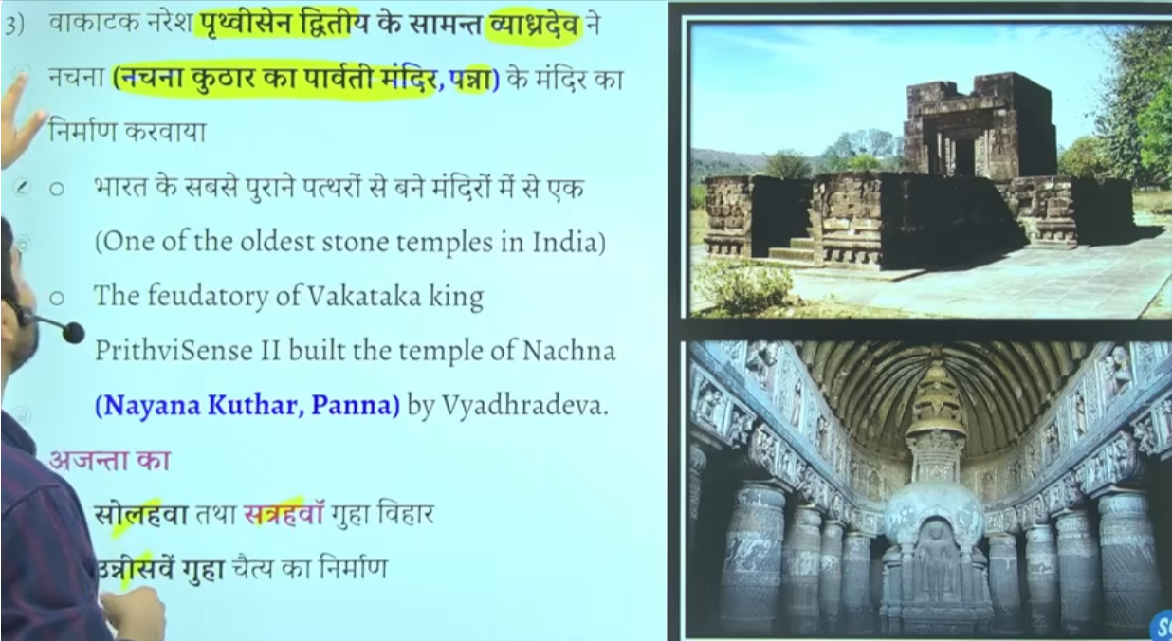

Nachna kudhar ka Parvati mandir panna me hai it is one of the oldest stone temple of india
Aur ajanta ki 16 17 and 19 ve cave me bhe inka yogdan rahah hai vaktaka ka

Praversena second ka shasahankal sahetya literature work k lyie important rahega
Praverssaena second ne khud ek kavya likha setuband jiske sansahodan mahavaki kalidas ne kyia tha

Vyagradeva jo ki prathvisena second ke samant the inhonr panna madhyapradehs me Nachna kudhar mandir ka Nirman kyia tha
4

